

Weekly report

{system:name}
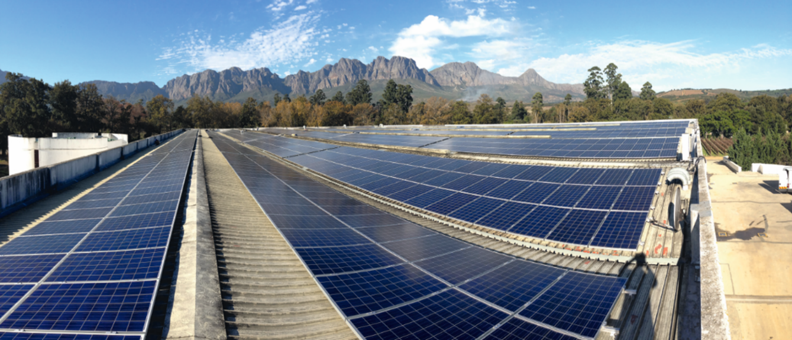
Site | {system:postcode}, {system:city}, {system:country}
Peak power | {system:performance} kWp
Reporting period | {report:timeSpan}

- Explanation of concepts

- Energy yield: Produced energy of the PV system as measured by the energy meter. Unit: kWh.

- Specific yield: The energy production normalized to the installed peak power of {system:performance} kWp. Unit: kWh/kWp.

- Irradiance: Solar irradiance on the module plane as measured by the sensors installed on-site. Unit: W/m2.

- Simulated yield: Forecast of how much power will be produced in kWh based on the system configuration (modules, inverters, mounting system) and the measured irradiance. Unit: kWh.

- System availability: Percentage calculated based on the equations defined in the O&M contract.

- Performance ratio: The quotient of the specific yield and irradiance on the module plane.

- Energy yield
  - Overview of reporting period

In {mdMonth:calc.month} the PV system generated a total amount of {mdMonth:calc.E_ZAEHLER} kWh. Accordingly, the specific yield of the installed capacity was {mdMonth:calc.E_N} kWh/kWp.

The reporting period was characterized by a global irradiance at the module level of {mdMonth:ad.G_M0} Wh/m².

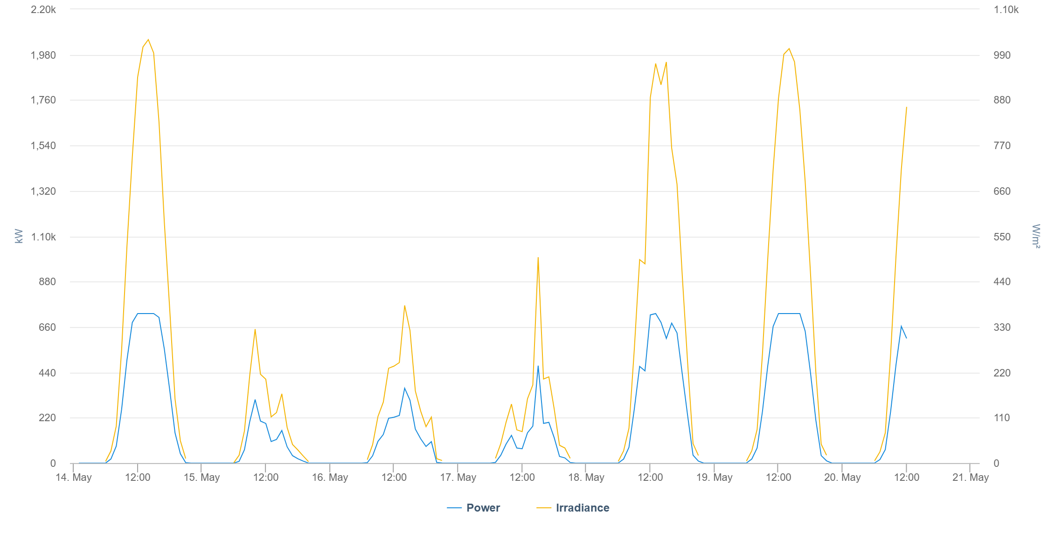Energy yield of PV system in the current week

 | Energy yield  kWh | Specific yield  kWh/kWp | Irradiance  W/m2 | System availability
{START}{mdDay:calc.date} | {mdDay:calc.E_ZAEHLER} | {mdDay:calc.E_N} | {mdDay:sim.E_Z_EVU} | {mdDay:calc.VFG} %

{mdMonth:calc.month} | {mdMonth:calc.E_ZAEHLER} | {mdMonth:calc.E_N} | {mdMonth:calc.E_GM} | {mdMonth:calc.VFG} %
Energy yield, specific yield, irradiance and system availability for the current period

- Yield forecast and variance analysis

  - Variance analysis chart

The following chart compares the actual and simulated energy yields in the current period.

- If the measured energy is in the range 90% - 115% compared to the simulation value, the system is performing very well (green).

- If the measured energy is in the range 70% - 90% compared to the simulation value, the system is performing satisfactorily (yellow).

- If the measured energy is in the range 0% -70% compared to the simulation value, the system must be checked (red).

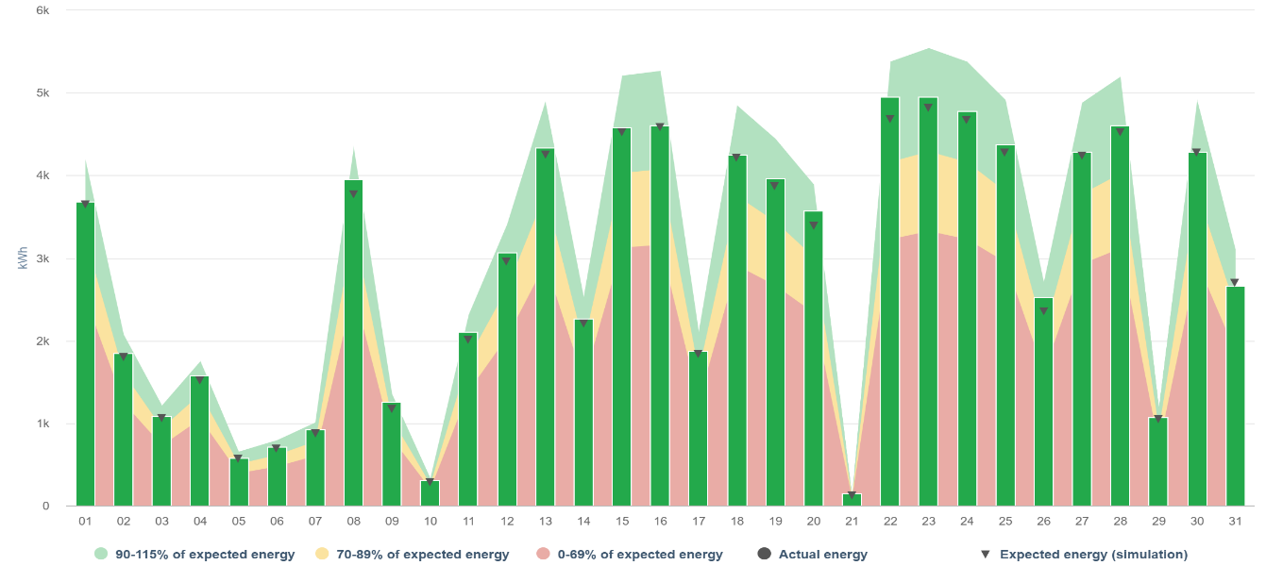
Variance analysis for the current period
  - Variance analysis values

Period | Energy yield  kWh | Simulated yield  kWh
Current month  ({mdMonth:calc.month}) | {mdMonth:calc.E_ZAEHLER} | {mdMonth:sim.E_Z_EVU}
Current year  ({mdYear:calc.year}) | {mdYear:calc.E_ZAEHLER} | {mdYear:sim.E_Z_EVU}
Actual energy yield compared to simulated yield for the current week

- Energy yield values

  - Monthly and yearly values

 | Energy yield  kWh | Specific yield  kWh/kWp | Irradiance  Wh/m²
{START}Sum {mdMonth:calc.month} | {mdMonth:calc.E_ZAEHLER} | {mdMonth:calc.E_N} | {mdMonth:calc.E_GM}
Sum {ep:year} | {mdYear:calc.E_ZAEHLER} | {mdYear:calc.E_N} | {mdYear:calc.E_GM} {END}
Energy yield, specific yield, and irradiance for the current month and year

  - Daily values

 | Energy yield  kWh | Specific yield  kWh/kWp | Irradiance  Wh/m²
{START}{mdDay:calc.date} | {mdDay:calc.E_ZAEHLER} | {mdDay:calc.E_N} | {mdDay:calc.E_GM}
Daily energy yield, specific yield, and irradiance values

- Power control history (curtailments)

The following table shows all active power curtailments of your system during the current period. The table also includes the yield loss due to curtailments and the ticket ID if relevant.

Start | End | Duration | Setpoint  % | Losses  kWh | Source | Ticket ID
{START}{powercontrol:start} | {powercontrol:end} | {powercontrol:duration} | {powercontrol:setpoint} | {powercontrol:losses} | {powercontrol:source} | {powercontrol:ticketid}{END}
Active power curtailments during the current period

- Incidents

The following table shows all unresolved incidents (= open tickets) during the current period.

{START}Ticket-Id | {fp:ticketid} | {fp:begin} | to | {fp:closed} |  | Status | {fp:status}
Incident | {fp:description} |  |  |  | Yield loss: |  | kWh
Summary | {fp:summary}
 |  |  |  |  |  |  | {END}
Unresolved incidents during the current period

