

Monthly report

{system:name}
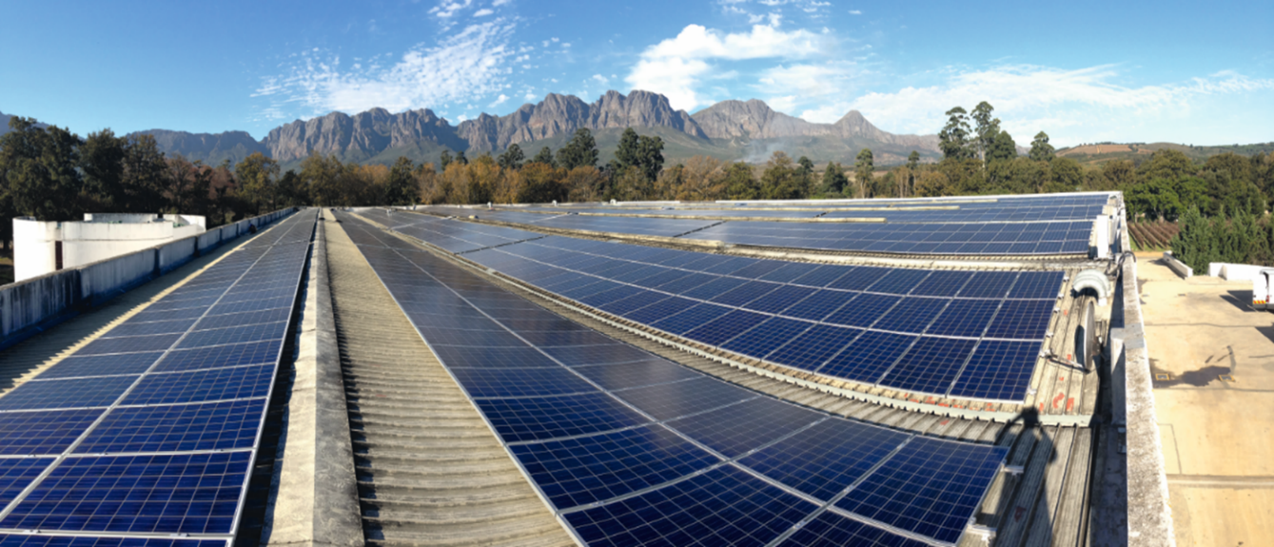
Site | {system:postcode}, {system:city}, {system:country}
Peak power | {system:performance} kWp
Reporting period | {mdMonth:calc.month}

- Explanation of concepts

- Energy yield: Produced energy of the PV system as measured by the energy meter. Unit: kWh.

- Specific yield: The energy production normalized to the installed peak power of {system:performance} kWp. Unit: kWh/kWp.

- Irradiance: Solar irradiance on the module plane as measured by the sensors installed on-site. Unit: W/m2.

- Simulated yield: Forecast of how much power will be produced in kWh based on the system configuration (modules, inverters, mounting system) and the measured irradiance. Unit: kWh.

- System availability: Percentage calculated based on the equations defined in the O&M contract.

- Performance ratio: The quotient of the specific yield and irradiance on the module plane.

- Energy yield
  - Overview of reporting month

In {mdMonth:calc.month} the PV system generated a total amount of {mdMonth:calc.E_ZAEHLER} kWh. Accordingly, the specific yield of the installed capacity was {mdMonth:calc.E_N} kWh/kWp.

The reporting month was characterized by a global irradiance at the module level of {mdMonth:ad.G_M0} Wh/m²
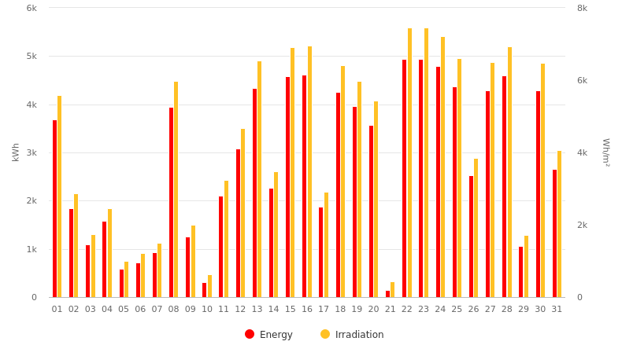
Figure 1 Energy yield of PV system in the current month.
 | Energy yield  kWh | Specific yield  kWh/kWp | Simulated yield  kWh
{START}{mdDay:calc.date} | {mdDay:calc.E_ZAEHLER} | {mdDay:calc.E_N} | {mdDay:sim.E_Z_EVU}

{mdMonth:calc.month} | {mdMonth:calc.E_ZAEHLER} | {mdMonth:calc.E_N} | {mdMonth:sim.E_Z_EVU}
Table 1 Energy yield, specific yield and simulated yield for the current month

  - Overview of the current year
In the year {ep:year} the PV system generated in total {mdYear:calc.E_ZAEHLER} kWh of electricity. Accordingly, a specific production of {mdYear:calc.E_N} kWh/kWp could be achieved so far.

In the operating year, a global irradiance of {mdYear:ad.G_M0} Wh/m² was determined for the system location by the irradiance sensor installed at the module level.

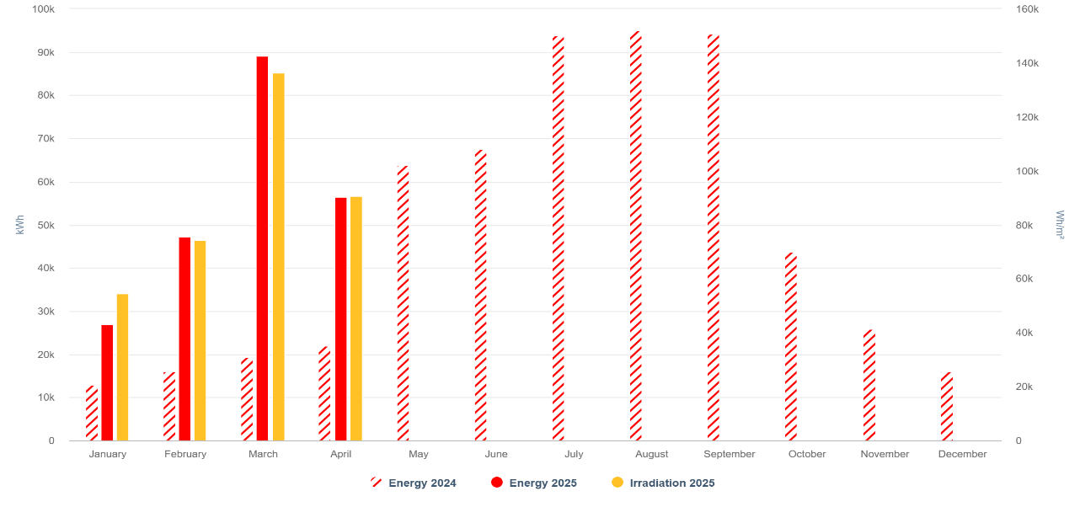
Figure 2 Energy yield of PV system in the current year

The following table summarize the daily values as well as the sum of the current month:

- Energy yield: Produced energy of the PV system in kWh, as measured by the energy meter.

- Specific yield: The energy production normalized to the installed peak power of {system:performance} kWp.

- Irradiance: Solar irradiance on the module plane in W/m2 as measured by the sensors installed on-site.

The actual energy yield of the PV system for the current month and year is compared with the simulated nominal yield values. The simulation takes the system configuration (modules, inverters, mounting system) and the measured irradiance into account.

Period | Energy yield  kWh | Specific yield  kWh/kWp | Simulated yield  kWh
Current month  ({mdMonth:calc.month}) | {mdDay:calc.E_ZAEHLER} | {mdDay:calc.E_N} | {mdDay:sim.E_Z_EVU}
Current year  ({mdYear:calc.year}) | {mdMonth:calc.E_ZAEHLER} | {mdMonth:calc.E_N} | {mdMonth:sim.E_Z_EVU}
Table 2 Energy yield, specific yield, and simulated yield for the current month and year

- Key performance indicators
  - Performance ratio
The performance ratio equals the quotient of the specific yield and irradiance on the module plane. For the system {system:name} the calculation of the PR is based on the values of {pr:energySource} for the specific yield and the {pr:irradiationSource} for the irradiance. The aggregation for the monthly value is based on the source {pr:aggregation}.

The performance ratio for {mdMonth:calc.month} is {mdMonth:calc.PR} %.
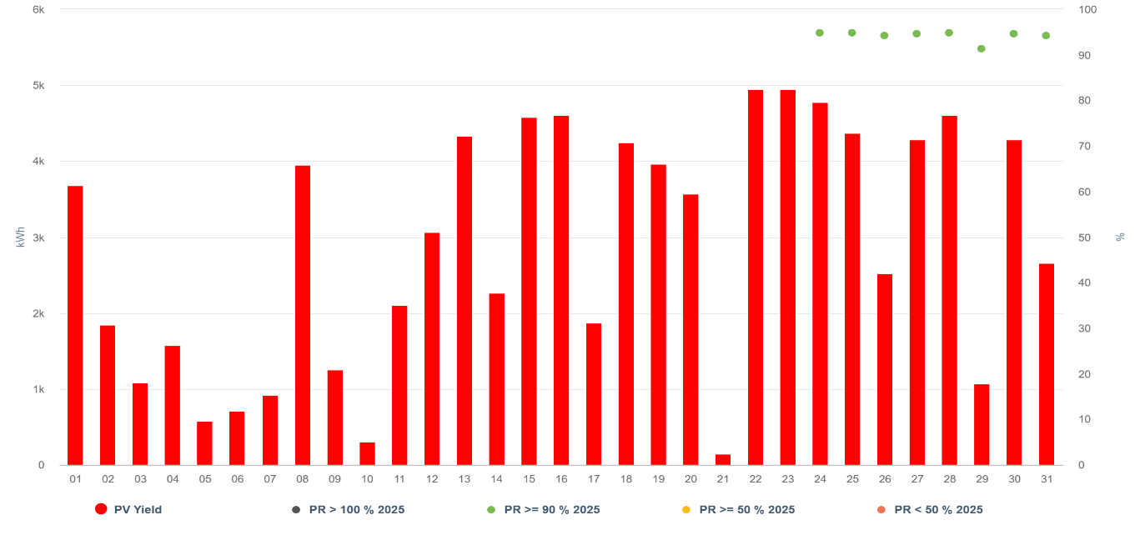
Figure 3 Performance ratio for the current month

  - System availability

The system availabilitly is calculated based on the equations defined in the O&M contract. For {mdMonth:calc.month} the system reached a system availability of {mdMonth:calc.VFG} %.

Therefore, the irradiance threshold value is {systemAvailability:irradianceThreshold}.

- Yield forecast and variance analysis

  - Monthly variance analysis

The following chart compares the actual and simulated yields in the current month.

- If the measured energy is in the range 90% - 115% compared to the simulation value, the system is performing very well (green).

- If the measured energy is in the range 70% - 90% compared to the simulation value, the system is performing satisfactorily (yellow).

- If the measured energy is in the range 0% -70% compared to the simulation value, the system must be checked (red).

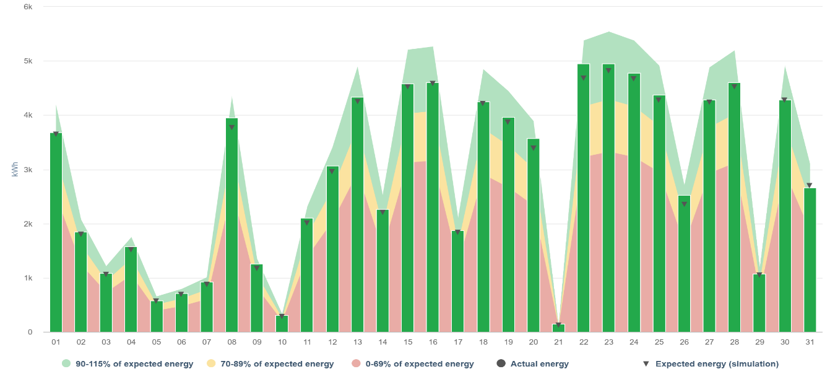
Figure 4 Variance analysis for the current month
  - Yearly variance analysis

The following chart compares the actual and simulated yields in the current year. It also shows the yield forecast based on a yield report with long-term irradiance data.

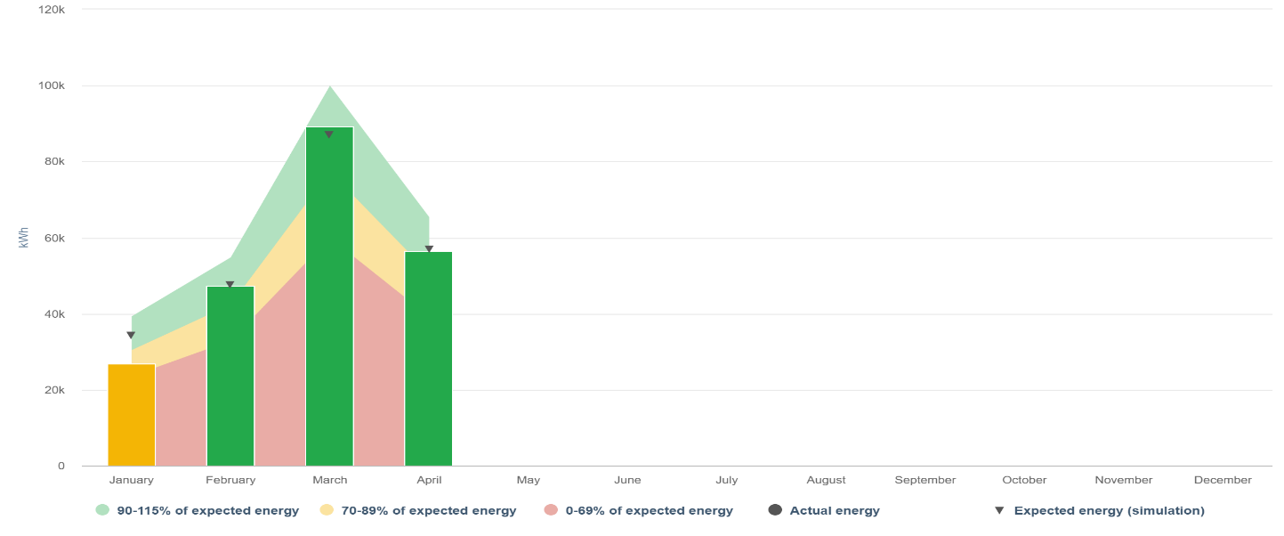
Figure 5 Variance analysis for the current year

  - Variance analysis values

In the following table, the annual specific yield of the system is compared to the specific yield based on a yield report.

Month | Specific yield  kWh/kWp | Specific yield of yield report  kWh/kWp
{START}{ep:month}.{ep:year} | {ep:SpecificYield} | {ep:YieldForecast} {END}
Table 3 Specific annual yield compared to specific yield forecast

- Energy yield values

  - Monthly and yearly values

 | Energy yield  kWh | Specific yield  kWh/kWp | Irradiance  Wh/m²
{START}Sum {mdMonth:calc.month} | {mdMonth:calc.E_ZAEHLER} | {mdMonth:calc.E_N} | {mdMonth:calc.E_GM}
Sum {ep:year} | {mdYear:calc.E_ZAEHLER} | {mdYear:calc.E_N} | {mdYear:calc.E_GM} {END}
Table 4 Energy yield, specific yield, and irradiance for the current month and year

  - Daily values

 | Energy yield  kWh | Specific yield  kWh/kWp | Irradiance  Wh/m²
{START}{mdDay:calc.date} | {mdDay:calc.E_ZAEHLER} | {mdDay:calc.E_N} | {mdDay:calc.E_GM}
Table 5 Daily energy yield, specific yield, and irradiance values

- Power control history (curtailments)

The following table shows all active power curtailments of your system during the past month. The table also includes the yield loss due to curtailments and the ticket ID if relevant.

Start | End | Duration | Setpoint  % | Losses  kWh | Source | Ticket ID
{START}{powercontrol:start} | {powercontrol:end} | {powercontrol:duration} | {powercontrol:setpoint} | {powercontrol:losses} | {powercontrol:source} | {powercontrol:ticketid}{END}
Table 6 Active power curtailments during the past month

